PARTNERSHIP AGRREMENT

between _____ and ISIC Portugal

ISIC Portugal, Exclusive Representative for Portugal of the ISIC, ITIC e IYTC cards, legally represented for this agreement by Pumpkintreasure LDA, with headquarters at Rua Ivens, 42 – 1º – 1200-227 Lisbon, Portugal, and VAT ID number 510 583 628, dully represented in this matter by Rogério Cardoso and Maria Manuel Melo, with legal powers to this agreement, and from now on referred as “ISIC Portugal"

and
_______, with headquarters at ____________, ___________, with VAT ID number __________, dully represented in this matter by _______________, with legal powers to this agreement, and from now on referred as “_____”

Considering:

- ISIC (International Student Identity Card) main objective is the international recognition of official full time Student status.

- ITIC (International Teacher Identity Card) main objective is the international recognition of official Teacher status.

- IYTC (International Youth Travel Card) main objective is to provide access to benefits of ISIC to the non-student audience aged thirty (30) years or younger.

Together, ISIC, ITIC and IYTC holders shall be hereinafter referred as ISIC Members.

- The ISIC is endorsed by UNESCO, supported by the European Council on Culture, the Andean Community of Nations and recognized by multiple Education Ministries, academic institutions and student unions worldwide.

- ISIC has, approximately, 5 million cards per year in active circulation in more than 130 countries.

- _____ operated in Portugal and its clientele encompasses customers in the student, teacher target and youth audience shared with ISIC.

Both parties have therefore decided to sign this agreement:

Article 1
Purpose
Purpose of the Agreement:
To define the terms and conditions in which _____ agrees to offer and promote discount benefits to ISIC Members per the following conditions.

Article 2
Conditions

2.1. This agreement is valid from the ______ onwards.
The agreement is valid for the period of one year and it shall automatically be renewed for additional one year periods, except if denounced by any of the parts, according to Article 4, Paragraph 4.1.

2.2. _______ will offer to ISIC Members:
...
...
...

Article 3
Obligations
3.1. ______ obligations
Under the terms of the present agreement, _____ shall:
- Offer and honour the benefit described in Article 2, Paragraph 2.2. of this contract to any ISIC Member (in accordance with the terms and conditions contained herein) who present a valid ISIC, ITIC and IYTC card or digital-version identity card displayed via the ISIC Association’s secure mobile web and app.
- Allow ISIC Portugal to use ______ name, discount offer and trademark(s) in promotional advertising for the ISIC/ITIC/IYTC national and global benefit platform.
- Provide specific graphical assets and marketing texts that can be used by the ISIC Exclusive Representative and the global ISIC Association on their websites, apps and social media.
- Submit to ISIC Portugal any advertising material and/ or promotional material that will include use of the ISIC, ITIC and IYTC trademark, branding or any other mention for its prior approval.
- Communicate all the benefits and conditions of the present agreement to all ______ staff.
- Communicate and make available through all different channels used, the offered benefits to all ISIC Members, including communicating ISIC Portugal website and social media addresses.
- Collect discount usage data by ISIC Members and share it with ISIC Portugal, in terms and frequency to be establish between parties.

3.2. ISIC Portugal obligations
Under the terms of the present agreement, ISIC Portugal must:
- Communicate and make available the offered benefits to all ISIC Members through ISIC Portugal official website, ISIC Association global website, ISIC Association app and other chosen communication channels.
- Submit to ______ any advertising material and/ or promotional material that will include use of ______ trademark, branding or any other mention for its prior approval.
- Maintain regular contact with ______ to, whenever possible, analyse the benefit usage, joint promotional activities, and, annually, to confirm and renew the present agreement.
- Ensure that an individual is eligible for the benefits offered by ISIC, ITIC and IYTC schemes, for example by verifying them as a student, teacher or under 30 years of age (as applicable) when they become an ISIC Member.
- Whenever possible, promote the benefits to ISIC Members to other agreed partners, encouraging the communication through their available channels.

Article 4
Termination

4.1. Either of the Parties to this agreement can terminate the agreement if, at any time, consider relevant motives will prevent full compliance of the established partnership, will prevent the full compliance of the rules that command his business activity, as well as any specific determinations or agreements both formal or informal, without the right to any compensation, whenever the claiming part communicate this will in writing to the other part.

4.2. Under the terms of Article 4, Paragraph 4.1., the termination will be considered effective thirty (30) days after receipt of written notice termination, which must include the reasons that lead to termination.

Article 5
Confidentiality
5.1. For the purpose of this agreement, Confidential Information shall be considered any information related to the contractual details between Parties, as well as other data, proprietary know-how, technical interfaces, processes, intellectual property, financial information, marketing data, that will be communicated by either Party to other in the course of this agreement, independent of the manner in which this Confidential Information is transmitted.

5.2. Both Parties agree not to disclose any Confidential Information to third parties without the previous specific written authorization of the other Party. Any Confidential Information acquired by any of the Parties during the duration of the present agreement will be used exclusively for the purposes of implementation of this agreement.

5.3. The obligations of Confidentiality defined in Article 5, Paragraph 5.1. and 5.2. shall continue unabated for both Parties for a period of five (5) years following any notice of termination served pursuant to Article 4.

Article 6
Data Protection
6.1. For the purpose of this Article the following definitions shall apply:

6.1.1. National Data Privacy directives will be adhered to by both Parties.
The transmission and use of data by the global ISIC Association will adhere to the European Union General Data Protection Regulation 2016/679.
Together described herewith as the Applicable Privacy Legislation (“APL”).

6.1.2. Data Processor: shall have the meaning set out in the APL.

6.1.3. Personal Data: shall have the meaning set out in the APL, and for the purposes of this Agreement only cover the subset of ISIC Members who have registered a discounted transaction with ______ pursuant to Article 2, Paragraph 2.2. of this agreement.

6.2. In the instance that ISIC Portugal or ______ receives a complaint, notice or communication which relates directly or indirectly to their processing of the Personal Data or to either Party’s compliance with the APL and the data protection directives valid under this agreement, it shall immediately notify the other Party and render full co-operation and assistance in relation to resolving any such complaint, notice or communication.

Article 7

Others

7.1. This agreement cannot be amended or modified, except if agreed and signed by both Parties.

7.2. Neither of the Parties is allowed to make this agreement available to any third party for review, without prior written consent of the other Party.

7.3. The construction, validity and performance of this agreement are governed by Portuguese laws and the parties agree to submit to the exclusive jurisdiction of the courts of Lisbon, with the exclusion of any other, any query or litigation related to interpretation, implementation or termination of this agreement.

Lisbon, __ of _____ of 2017

By _____ By ISIC Portugal

_____________________________ _____________________________
_____________________________
Rogério Cardoso
Maria Manuel Melo

Appendix 1: Sample of ISIC, ITIC and IYTC cards image

Appendix 2: Proprietary Rights and Trademark Usage

APPENDIX 1: Sample of ISIC, ITIC and IYTC Cards Image

Cartão ISIC Standard  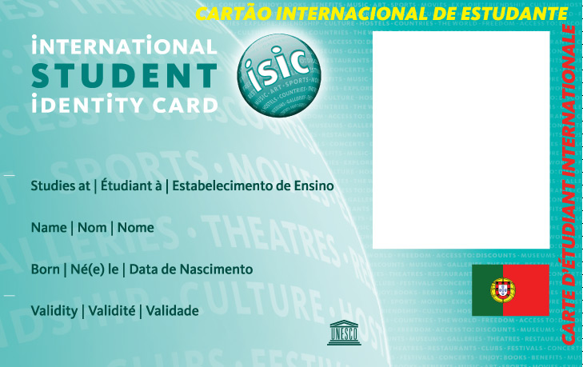 | Cartão Co-brand Financeiro  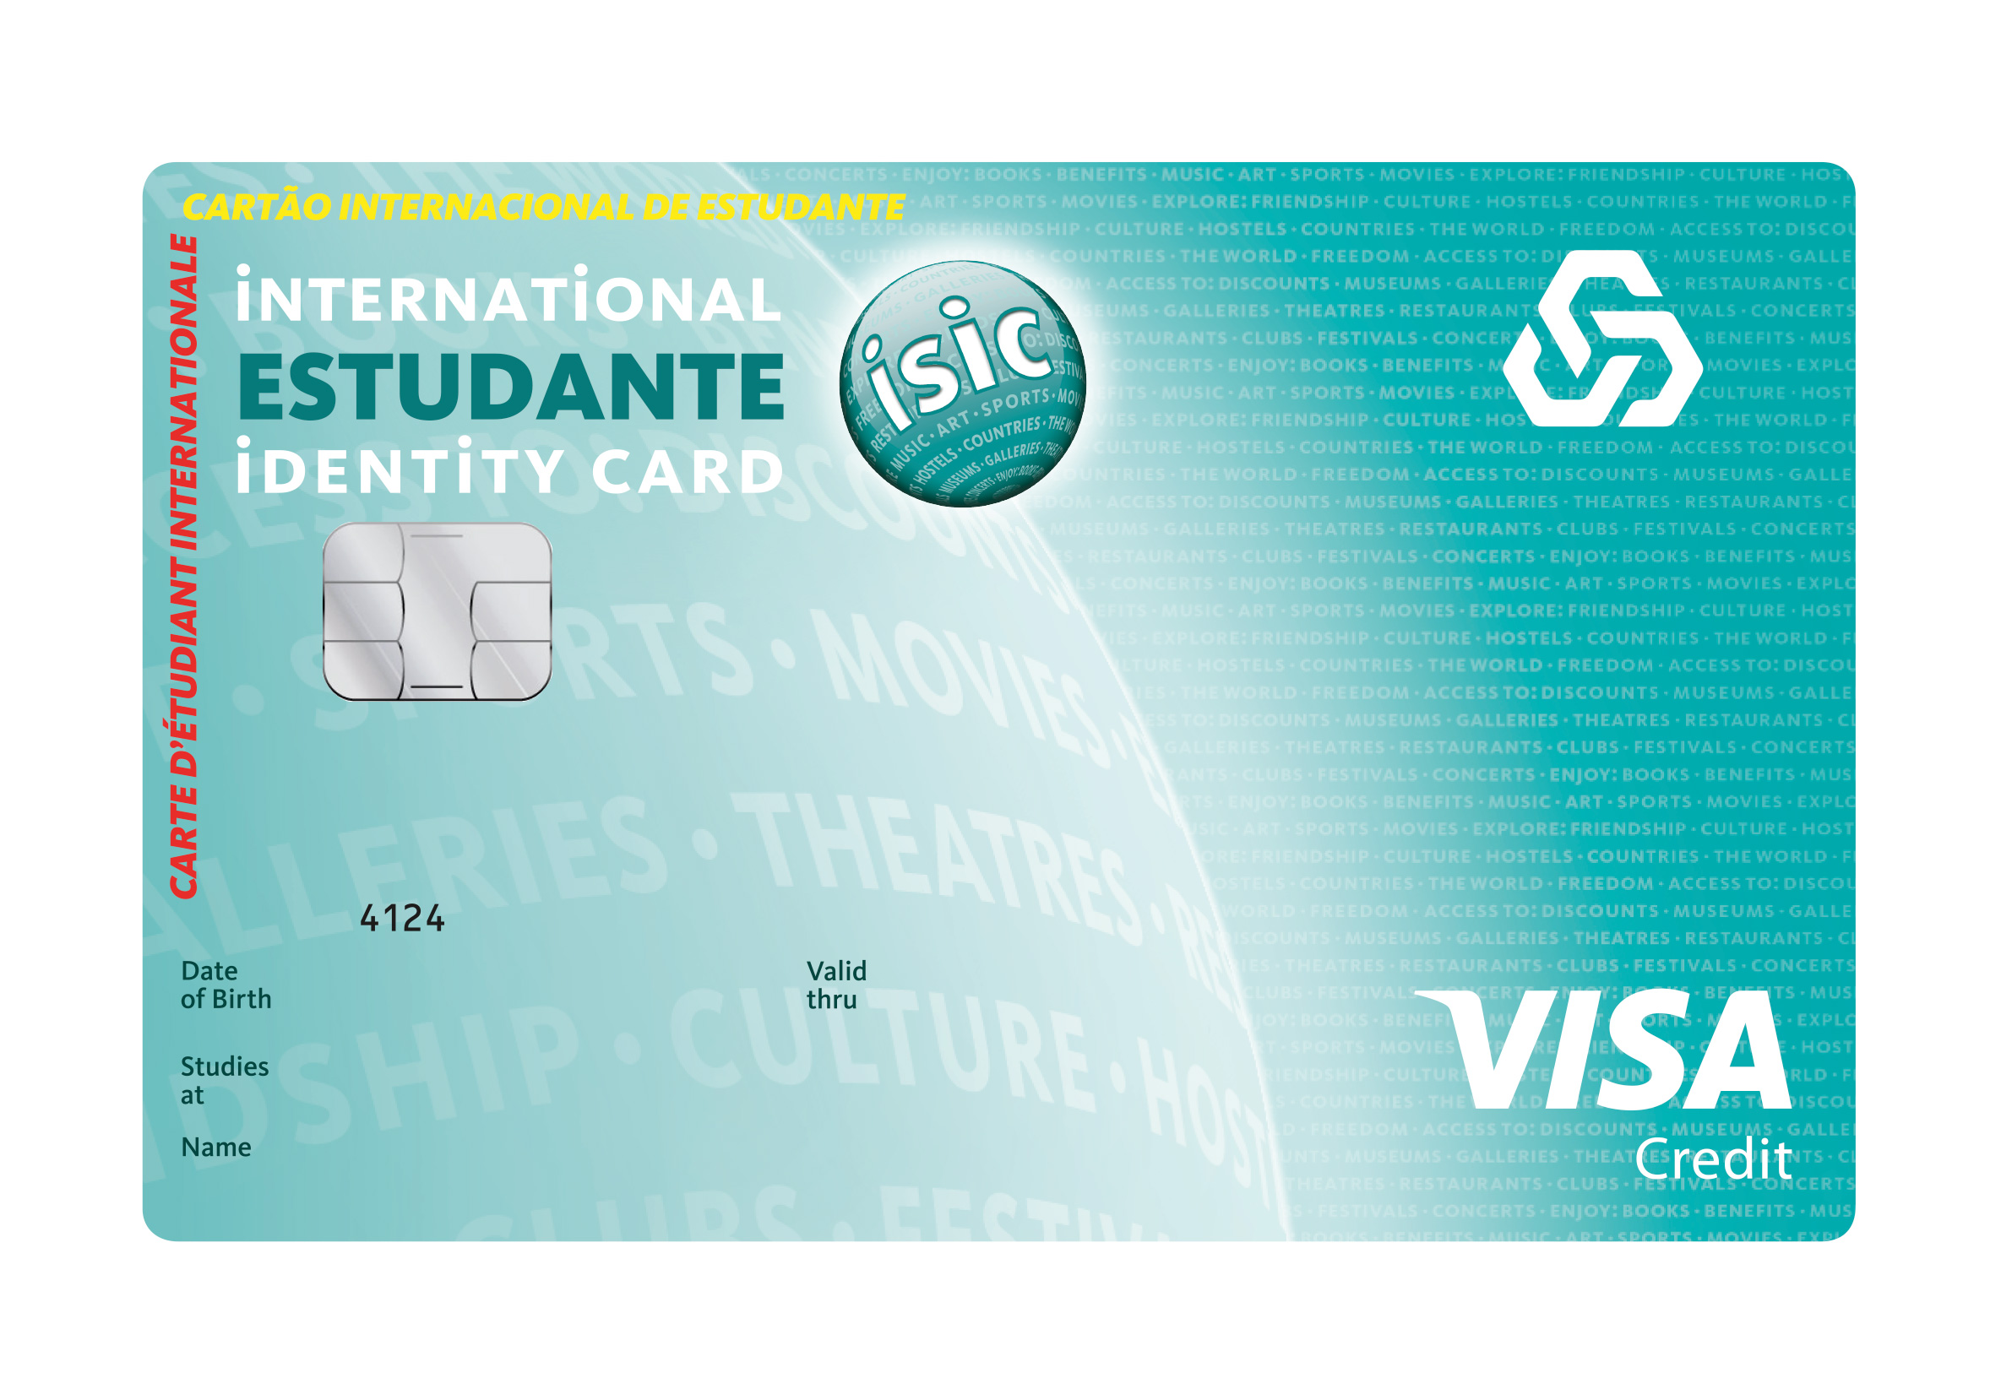
Cartão ITIC Standard  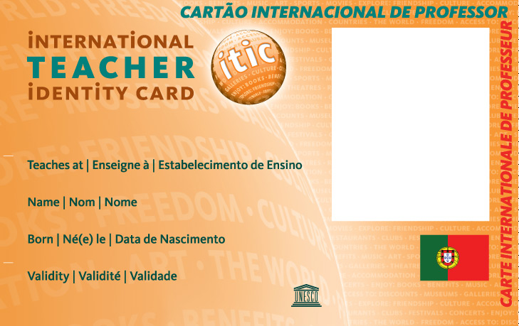 | Cartão Co-brand Académico  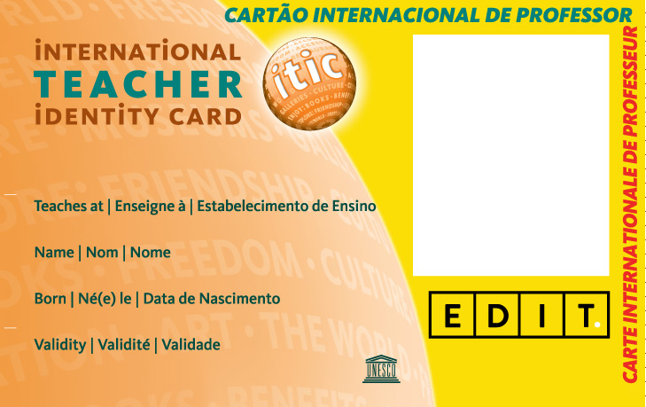
Cartão IYTC Standard  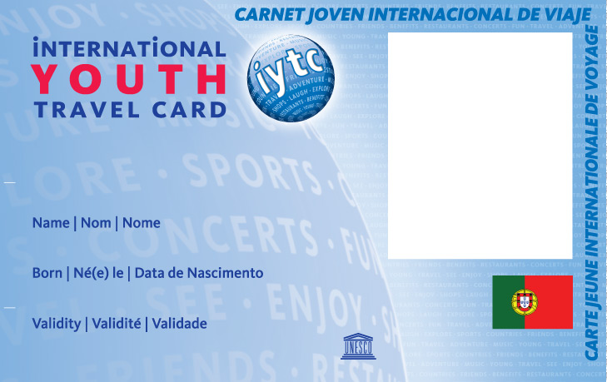 | Cartão Co-brand Comercial  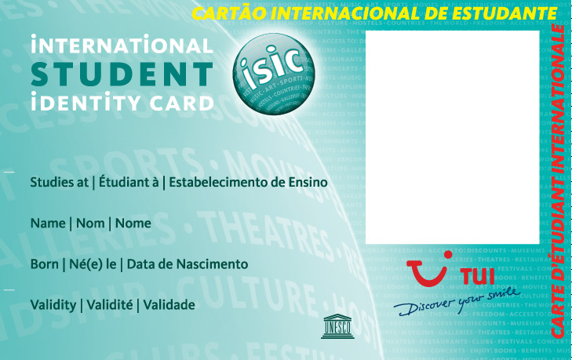
Cartões Virtuais

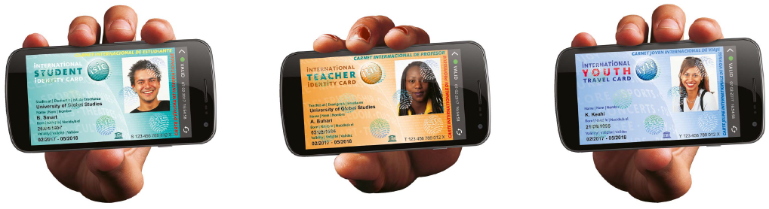
APPENDIX 2: Proprietary Rights and Trademark Usage

_____ grants ISIC Portugal and the global ISIC Association a royalty free, non-exclusive, worldwide license, for the duration of this Partnership Agreement, solely to promote and advertise the offer elaborated in Article 2, Paragraph 2.2. with the use of promotional materials, provided by _____, including the use of trademarks and advertising materials (“Promotional Materials”).
ISIC Portugal and the global ISIC Association may display, reproduce, re-publish and/or distribute the Promotional Materials in order to promote said offer.
O ISIC Portugal acknowledges that _____ and its licensors retain all rights, title and interest, including without limitation all rights in copyrights, trademarks, trade secrets, patents and know-how, in relation to the _____ Promotional Materials, and any other advertising materials or intellectual property provided by _____ to ISIC Portugal.
O ISIC Portugal has, and shall acquire no rights in the foregoing except those expressly granted herein.
In addition, except as expressly provided herein, ISIC shall not tamper, alter, modify in any way or make any addition to the Promotional Materials or any other Intellectual Property or materials provided _____, without _____ prior written agreement.

O ISIC Portugal grants ____ a royalty free, non-exclusive license, for the duration of this Partnership Agreement, solely to promote and advertise the Offer elaborated in Article 2, Paragraph 2.2. with the use of the promotional materials, provided by ISIC Portugal, including the use of trademarks and advertising materials (“Promotional Materials”) in Portugal.
_____ may display, reproduce, re-publish and/or distribute the Promotional Materials in order to promote said offer.
_____ acknowledges that ISIC Exclusive Representative retains all rights, title and interest, including without limitation all rights in copyrights, trademarks, trade secrets, patents and know-how, in relation to the Promotional Materials, the Offer and any other advertising materials or intellectual property provided by ISIC Portugal to _____.
_____ shall acquire no rights in the foregoing except those expressly granted herein.
In addition, except as expressly provided herein, _____ shall not tamper, alter, modify in any way or make any addition to the Promotional Materials or any other Intellectual Property or materials provided by ISIC Portugal without prior written consent.

