ISIC Portugal, Exclusive Representative for Portugal of the ISIC, ITIC e IYTC cards, legally represented for this agreement by Pumpkintreasure LDA.

Organisation/ Name of Business:

Type of Business:

- Accommodation
- Education
- Food & Drinks
- Museums & Culture
- Transportation
- Entertainment
- Retail Shops
- Services
- Travel
- Sport and Activities
- Technology
- Health and Beauty

Information about the Organisation

Business address:
Post Code:
City:
Country:
Telephone Number:
Public email address:
Website address:

Information about the organisation that will not be accessible to our cardholders. It’s for ID cards Dept. use ONLY.

Contact at company:
Title/ Position:
Telephone Number:
Email address:

Offer valid globally for all ISIC Members. Please select the cards you would like to exclude from this agreement.
- ISIC – International Student Identity Card – full-time students
- ITIC - International Teacher Identity Card – full-time teachers and professors
- IYTC - International Youth Travel Card – Youths under 30

Description of Offer:
Please supply a description of the discount/ benefit.

Benefit validity:
Please supply the date(s) your offer is valid for.

Conditions and Restrictions:
Mark (x) any conditions and restrictions that apply to the discount/ benefit.
- Advance Reservation required
- Not valid with other discounts
- Promo Code (specify)
- Time of day (specify)
- Day of week (specify)
- Online purchase only
- Not valid for ISIC virtual cards

Description of your business/ organisation:
Please supply a “blurb” about your product/services for us to include in your listings.

ISIC issues cards in more than 130 countries. Would you like to extend the offer to other countries besides Portugal?

- Yes
- No

If yes, which countries?

Marketing and Promotion opportunities with a free product donation:
By donating a free product to ISIC Portugal, the following marketing opportunities are available:
- A product giveaway featured on one of our social channels to increase awareness and engagement around your product offering.
- A product review available in one of the following formats: Instagram story & Facebook Story / Instagram live video / ISIC product review video shared across all social channels.

- We will provide a product donation to ISIC Portugal
Details of donation:

Under the terms of the present agreement, your establishment agrees to:
- Offer and honour the benefit described in this contract to any ISIC Member (in accordance with the terms and conditions contained herein) who present a valid ISIC, ITIC and IYTC card or digital-version identity card displayed via the ISIC Association’s secure mobile web and app.
- Familiarise your staff with the ISIC/ ITIC/ IYTC Benefit Program and communicate the benefit and conditions of the present agreement.
- Allow ISIC Portugal to use ______ name, discount offer and trademark(s) in promotional advertising for the ISIC/ITIC/IYTC national and global benefit platform.
- Provide specific graphical assets and marketing texts that can be used by the ISIC Exclusive Representative and the global ISIC Association on their websites, apps and social media.
- Collect discount usage data by ISIC Members and share it with ISIC Portugal, in terms and frequency to be establish between parties.
- Cardholders must identify themselves to enjoy the benefits and the Provider shall ensure that the Cards shown are valid. All validity dates are clearly imprinted at the bottom of all Cards. If the Provider has any doubts on the Card’s authenticity, it should contact ISIC immediately.
- Offer is valid until a written notice is submitted by the establishment at least 90 days prior to cancellation via email to info@isic.pt or by post to ISIC Portugal – Travessa do Carmo, 11 – 1º A, 1200-095 Lisbon, Portugal.

Under the terms of the present agreement, ISIC Portugal agrees to:
- Communicate and make available the offered benefits to all ISIC Members through ISIC Portugal official website, ISIC Association global website, ISIC Association app and other chosen communication channels.
- Submit to ______ any advertising material and/ or promotional material that will include use of ______ trademark, branding or any other mention for its prior approval.
- Maintain regular contact with ______ to, whenever possible, analyse the benefit usage, joint promotional activities, and, annually, to confirm and renew the present agreement.
- Ensure that an individual is eligible for the benefits offered by ISIC, ITIC and IYTC schemes, for example by verifying them as a student, teacher or under 30 years of age (as applicable) when they become an ISIC Member.

Lisbon, __ of _________ of 2019

Benefit Provider Authorised Signature
______________________________
Name and Position:

ISIC Portugal Authorised Signatures
______________________________
Rogério Cardoso
______________________________
Maria Manuel Melo

APPENDIX 1: Sample of ISIC, ITIC and IYTC Cards Image

ISIC Standard Financial Co-brand Card
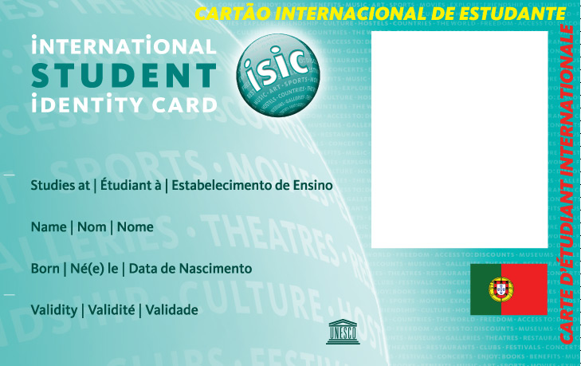
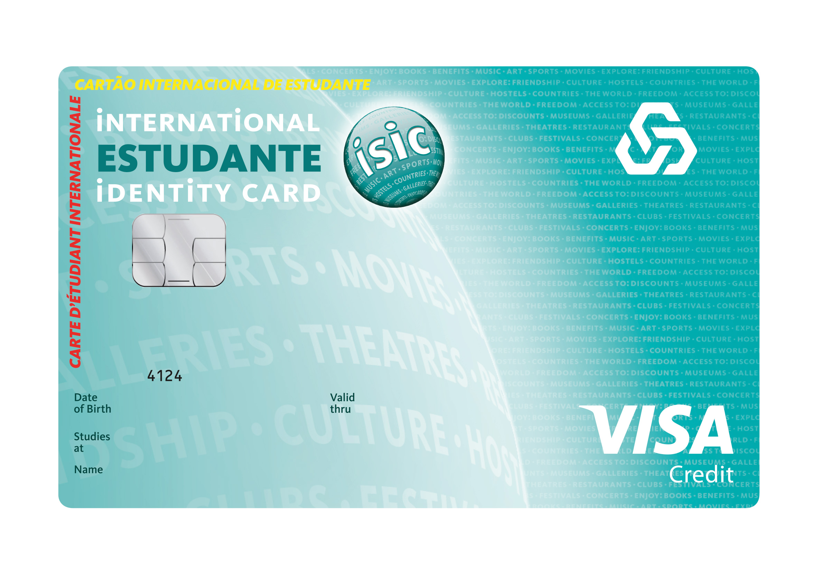

ITIC Standard Academic Co-brand Card
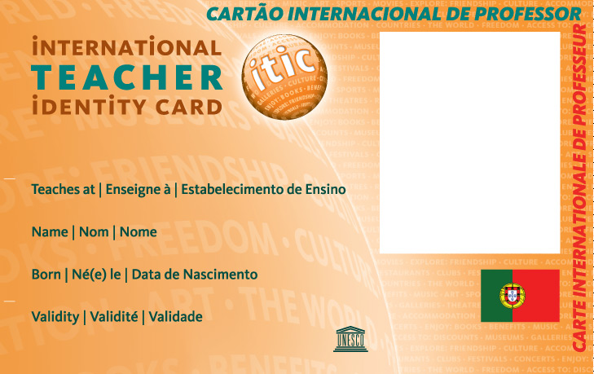
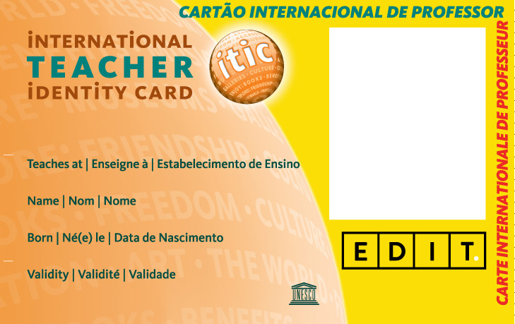

IYTC Standard Comercial Co-brand Card
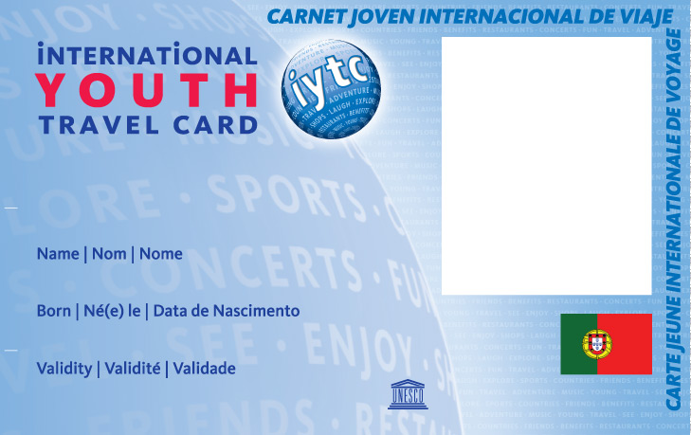
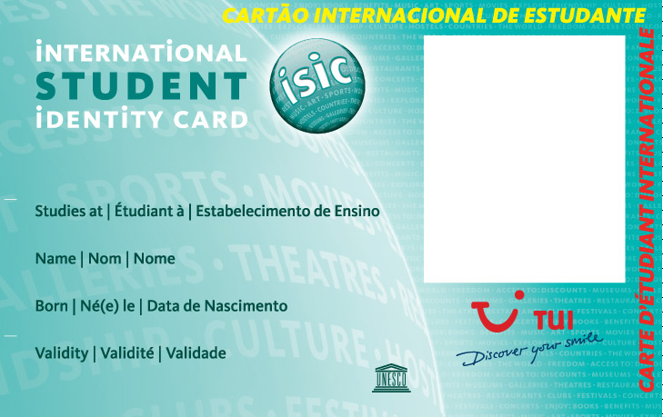

Virtual Cards
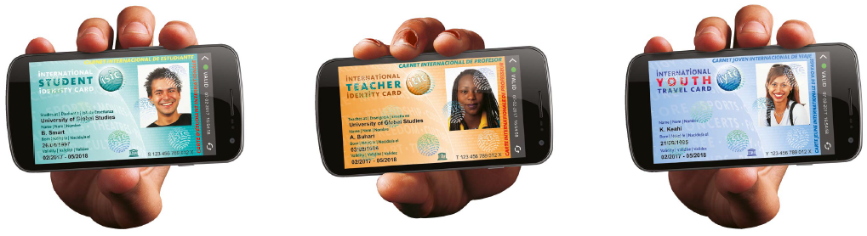

APPENDIX 2: Data Protection, Proprietary Rights and Trademark Usage

National Data Privacy directives are respected by both Parties.
The transmission and use of data by the global ISIC Association respects the European Union General Data Protection Regulation 2016/679.
Together described herewith as the Applicable Privacy Legislation (“APL”).
Personal Data: has the meaning set out in the APL, and for the purposes of this Agreement only cover the subset of ISIC Members who have registered a discounted transaction with ______ pursuant to this agreement.
In the instance that ISIC Portugal or ______ receives a complaint, notice or communication which relates directly or indirectly to their processing of the Personal Data or to either Party’s compliance with the APL and the data protection directives valid under this agreement, it shall immediately notify the other Party and render full co-operation and assistance in relation to resolving any such complaint, notice or communication.

_____ grants ISIC Portugal and the global ISIC Association a royalty free, non-exclusive, worldwide license, for the duration of this Partnership Agreement, solely to promote and advertise the offer described in this contract with the use of promotional materials, provided by _____, including the use of trademarks and advertising materials (“Promotional Materials”).
ISIC Portugal and the global ISIC Association may display, reproduce, re-publish and/or distribute the Promotional Materials in order to promote said offer.
ISIC Portugal acknowledges that _____ and its licensors retain all rights, title and interest, including without limitation all rights in copyrights, trademarks, trade secrets, patents and know-how, in relation to the _____ Promotional Materials, and any other advertising materials or intellectual property provided by _____ to ISIC Portugal.
ISIC Portugal has, and shall acquire no rights in the foregoing except those expressly granted herein.
In addition, except as expressly provided herein, ISIC shall not tamper, alter, modify in any way or make any addition to the Promotional Materials or any other Intellectual Property or materials provided _____, without _____ prior written agreement.

ISIC Portugal grants ____ a royalty free, non-exclusive license, for the duration of this Partnership Agreement, solely to promote and advertise the Offer described in this contract with the use of the promotional materials, provided by ISIC Portugal, including the use of trademarks and advertising materials (“Promotional Materials”) in Portugal.
_____ may display, reproduce, re-publish and/or distribute the Promotional Materials in order to promote said offer.
_____ acknowledges that ISIC Exclusive Representative retains all rights, title and interest, including without limitation all rights in copyrights, trademarks, trade secrets, patents and know-how, in relation to the Promotional Materials, the Offer and any other advertising materials or intellectual property provided by ISIC Portugal to _____.
_____ shall acquire no rights in the foregoing except those expressly granted herein.
In addition, except as expressly provided herein, _____ shall not tamper, alter, modify in any way or make any addition to the Promotional Materials or any other Intellectual Property or materials provided by ISIC Portugal without prior written consent.

